Weekly Snapshot
Week of May 27, 2019

Monday, May 27, 2019

Tuesday, May 28, 2019

Learning Strategies
Talk About it Tuesday
Goal Setting
UNIT: EXECUTIVE FUNCTIONING

6th Grade Weekly Selection: “The Earth Under Sky Bear’s Feet”
Introduction: Vocabulary
Activating Prior Knowledge: watch video on Native American history
Focus on Genre- myth
Read Aloud and Discuss Elements- Making Inferences
Homework- no homework

7th Grade Weekly Selection: Washington History Project
Students will complete Slide #4 in Sway

8th Grade Weekly Selection: “Handle with Care”
Introduction: Vocabulary
Activating Prior Knowledge- video on air pollution
Focus on Genre- persuasive essay
Read Aloud and Discuss Elements- arguments and evidence
Homework- none

Wednesday, May 29, 2019

Learning Strategies
Work on It Wednesday
Check Grades and Conference
Please check with your child about missing assignments and grades below C

6th Grade Weekly Selection: “The Earth Under Sky Bear’s Feet”
Review Vocabulary & Homework
Audio of Story
Grammar- prepositions
Homework-none

7th Grade Weekly Selection: Washington History Project
Students will complete Slide #5 in Sway

8th Grade Weekly Selection: “Handle with Care”
Review Vocabulary & Homework
Audio of Story
Grammar- use verbs in the present, past, and future tense
Homework- none

Thursday, May 30, 2019

Learning Strategies
Think About it Thursday
UNIT: EXECUTIVE FUNCTIONING

6th Grade Weekly Selection: “The Earth Under Sky Bear’s Feet”
Paired Reading of Text
Literary Analysis: Inferences
Text Structure: Inferences
Homework: Academic Vocabulary

7th Grade Weekly Selection: Washington History Project
Students will complete Slide #6 in Sway

8th Grade Weekly Selection: “Handle with Care”
Paired Reading of Text
Vocabulary Study: argument and reasons
Homework: Reading: none

Friday, May 31, 2019

Learning Strategies
Preferred and Non-Preferred Grouping
UNIT: EXECUTIVE FUNCTIONING

6^{th,} & 8th Grade Weekly Selection
Reading Test
Writing Assessment Linked to Current Story

7th Grade Weekly Selection: Washington History Project
Students will complete Slide #7 in Sway

Vocabulary
“The Earth Under Sky Bear’s Feet”

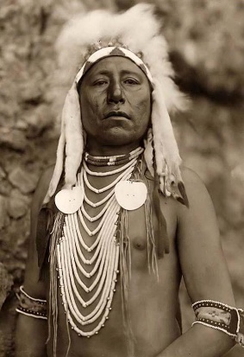

advice– a suggestion or idea that helps someone decide what to do

continue – to keep going

hunter – a person who looks for wild animals to capture or kill

remain – to stay in the same place

roam– to wander or to travel without any particular place to go

scatter –to throw away or drop thins over a wide area

tale– is a story

track – a footprint or a mark left by something as it moves over a surface

Vocabulary
“Handle with Care”

damage – means to cause harm

issue- a problem or a concern

prevent– means to keep it from happening

protect –to keep safe

recycle- means to use again, but in a different way

resource- something you can use

source- where something comes from

waste-something that is left over or thrown away

