Weekly Snapshot
Week of January 21, 2019

Monday, January 21, 2019
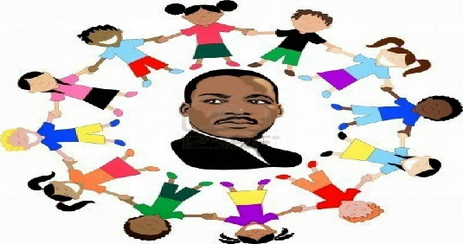
Tuesday, January 22, 2019

Learning Strategies
Talk About it Tuesday
STRESS: Conflict Resolution & Organization and Yoga

6th Grade Weekly Selection: “Frankenstein”
Introduction: Vocabulary
Activating Prior Knowledge: Video on: Frankenstein
Focus on Genre-Fantasy
Read Aloud and Discuss Elements-Character, Setting, and Plot
Homework-Workbook Vocabulary

8th Grade Weekly Selection: “Encounter”
Introduction: Vocabulary
Activating Prior Knowledge: Video on What is Historical Fiction?
Focus on Genre- Historical Fiction
Read Aloud and Discuss Elements- Analyze Plot, Characters, and Setting
Homework-Workbook vocabulary
Wednesday, January 23, 2019

Learning Strategies
Work on It Wednesday- Conference & Chat
Please check with your child about missing assignments and grades below C
STRESS: Conflict Resolution & Organization and Yoga

6th Grade Weekly Selection: “Frankenstein”
Review Vocabulary & Homework
Audio of Story
Grammar- Adjectives
Homework- Adjectives

8th Grade Weekly Selection: “Encounter”
Review Vocabulary & Homework
Audio of Story
Grammar- Verbs in the presence tense
Homework- Verbs in the presence tense
Thursday, January 24, 2019

Learning Strategies
Think About it Thursday
STRESS: Conflict Resolution & Organization and Yoga

6th Grade Weekly Selection: “Frankenstein”
Review Vocabulary & Homework
Audio of Story
Word Works and Analyze Text Features: Prefixes & Analyze Character Development
Homework-Academic Vocabulary

8th Grade Weekly Selection: “Encounter”
Review Vocabulary & Homework
Audio of Story
Word Works & Analyze Text Features: Analyze lot, Setting, and Character & Personification
Homework: Academic Vocabulary

Friday, January 25, 2019

Learning Strategies
Preferred and Non-Preferred Grouping
STRESS:

All Grades Weekly Selection
Reading Test
Reading Assessment Open Response Questions (new writing assessment)

Vocabulary
“Frankenstein”

create – means to make something new

creature – a real or imaginary living thing

destroy- means to take it apart of to ruin it

evil – very bad or harmful

experiment – an activity that someone does to test an idea

hideous – very ugly

lonely –means to be alone, without friends

scientist –a person who studies science

Vocabulary
“ENCOUNTER”

custom – is something that a certain group of people usually do

desire – you really want it

dream – a thought or an image in your mind when you sleep

encounter – is a meeting

shore- the land beside a large body of water

stranger- someone you do not know

warning – lets you know that there is a danger ahead

welcome– to greet a person kindly

