Weekly Snapshot
Week of January 28, 2019

Monday, January 28, 2019

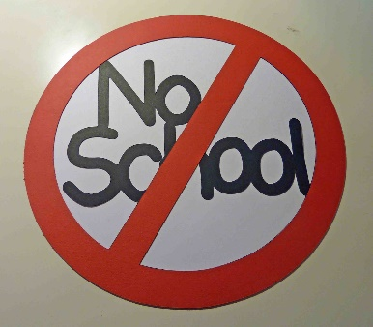
Tuesday, January 29, 2019

Learning Strategies
Talk About it Tuesday
Stress: Conflict Resolution

6th Grade Weekly Selection: “Film Fright”
Introduction: Vocabulary
Activating Prior Knowledge: watch video on making films
Focus on Genre- Feature Article
Read Aloud and Discuss Elements- Visualize
Homework- Learn Key Vocabulary

7th & 8th Grade Weekly Selection: “Culture Clash”
Introduction: Vocabulary
Activating Prior Knowledge- brief video on the Aztec Empire
Focus on Genre- History Article
Read Aloud and Discuss Elements- Understand realia, maps, and primary source text
Notetaking: Prepare to Read “Comparing a topic
Homework-Learn Key Vocabulary

Wednesday, January 30, 2019

Learning Strategies
Work on It Wednesday
Check Grades and Conference
Please check with your child about missing assignments and grades below C

6th Grade Weekly Selection: “Film Fright”
Review Vocabulary & Homework
Audio of Story
Grammar- Adjectives that make comparisons
Homework-Adjectives that make comparisons

7th & 8th Grade Weekly Selection: “Culture Clash”
Review Vocabulary & Homework
Audio of Story
Grammar-Verbs in the Past Tense
Homework-Verbs in the Past Tense

Thursday, January 31, 2019

Learning Strategies
Think About it Thursday
Stress: Conflict Resolution

6th Grade Weekly Selection: “Film Fright”
Paired Reading of Text
Literary Analysis: Analyze Rhythm in Poetry
Vocabulary Study: Use Latin and Greek Roots
Homework: Academic Vocabulary

7th & 8th Grade Weekly Selection: “Culture Clash”
Paired Reading of Text
Vocabulary Study: Idioms & Context Clues
Homework: Idioms

Friday, February 1, 2019

Learning Strategies
Preferred and Non-Preferred Grouping
Stress: Conflict Resolution

6^{th,} 7th , & 8th Grade Weekly Selection
Reading Test
Writing Assessment Linked to Current Story

Vocabulary
“Film Fright”

actor – a person who acts in a movie or play

character – someone in a story

classic – old, but good

fascinated – to be very interested in something

original –the first of its kind

process –a set of actions taken to get a certain result

successful –to have a good result or be well liked

terror – to have much fear

Vocabulary
“Culture Clash”
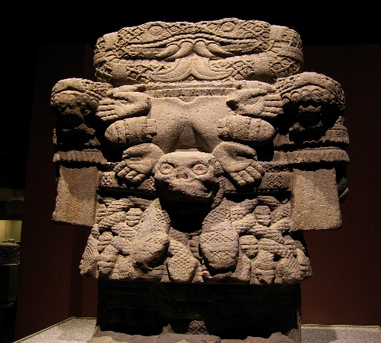

blend –to mix things together

capital – city where the government is located

conflict – a problem or disagreement

conquer – to win control of people through force

culture- the way of life for a group of people

defeat- is a loss

empire – a large group of areas ruled by one person

ruler – a person who runs a country

