Weekly Snapshot
Week of April 15, 2019

Monday, April 15, 2019
Learning Strategies
Mindfulness Monday
Goal Setting
UNIT: Psychology (Values)

6th Grade Weekly Selection: “Mysteries of the Ancient Past”
Introduction: Vocabulary
Activating Prior Knowledge: watch video on King Tut
Focus on Genre- History Article
Read Aloud and Discuss Elements- Ask Questions
Homework- Learn Key Vocabulary

7th Grade Weekly Selection: Washington History Project
Students will make Noodle Account for Online Notes

8th Grade Weekly Selection: “Zlateh the Goat”
Introduction: Vocabulary
Activating Prior Knowledge-
Focus on Genre- classic short story
Read Aloud and Discuss Elements-plot and theme
Homework-Learn Key Vocabulary
Tuesday, April 16, 2019

Learning Strategies
Talk About it Tuesday
UNIT: Psychology (Values)

6th Grade Weekly Selection: “Mysteries of the Ancient Past”
Review Vocabulary & Homework
Audio of Story
Grammar- Use of Verb Tense: Past Tense Verbs
Homework-Use of Verb Tense: Past Tense Verbs

7th Grade Weekly Selection: Washington History Project
Students will create SWAY slides in Office 365
Students will begin research on project.
Students will find the following information:
- 4 sources
- At least 3 videos
- 7-10 online photos to include in presentation

8th Grade Weekly Selection: “Zlateh the Goat ”
Review Vocabulary & Homework
Audio of Story
Grammar- Use pronouns in the subject and predicate
Homework-Use pronouns in the subject and predicate
Wednesday, April 17, 2019

Learning Strategies
Work on It Wednesday
Check Grades and Conference
Please check with your child about missing assignments and grades below C

6th Grade Weekly Selection: “Mysteries of the Ancient Past”
Paired Reading of Text
Literary Analysis: Sequence & Main Idea and Details
Text Structure: Suffixes & Prefixes
Vocabulary Study:
Homework: Academic Vocabulary

7th Grade Weekly Selection: Washington History Project
***STUDENTS WILL CONTINUE RESEARCH******************
Students will create SWAY slides in Office 365
Students will begin research on project.
Students will find the following information:
- 4 sources
- At least 3 videos
- 7-10 online photos to include in presentation

8th Grade Weekly Selection: “Zlateh the Goat”
Paired Reading of Text
Vocabulary Study: borrowed words
Analyze: Analyze Plot and Theme
Homework: “A Close Conflict to Home”- Close Reading
Thursday, April 18, 2019

Learning Strategies
Think About it Thursday
UNIT: Psychology (values)

ELA CLASSES
******************Practice for SBAC online ***********************************

Friday, April 19, 2019

Learning Strategies
Preferred and Non-Preferred Grouping
UNIT: Psychology

6^{th,} & 8th Grade Weekly Selection
Reading Test
Writing Assessment Linked to Current Story

7th Grade Weekly Selection: Washington History Project
Students will create online notecards for presentation
15-20 online notecards for full credit

Vocabulary
“Mysteries of the Ancient Past”

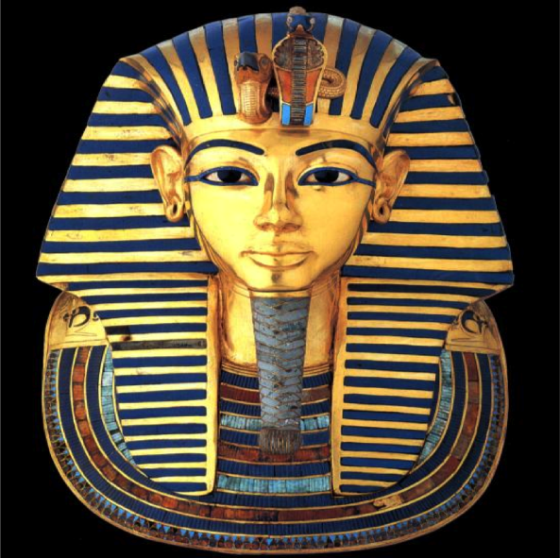

ancient – very old

archaeologist –a person who studies the way people lived in the past

artifact –an object, or the remains of one, that represents a culture

bury– means to place in the ground

civilization–the culture of a specific place, time, or group of people

clue –a piece of information that leads to a solution

pyramid–a building with a square base and four sides that are triangles

tomb– is a grave or a special place for the body of a dead person

Vocabulary
“Zlateh the Goat”
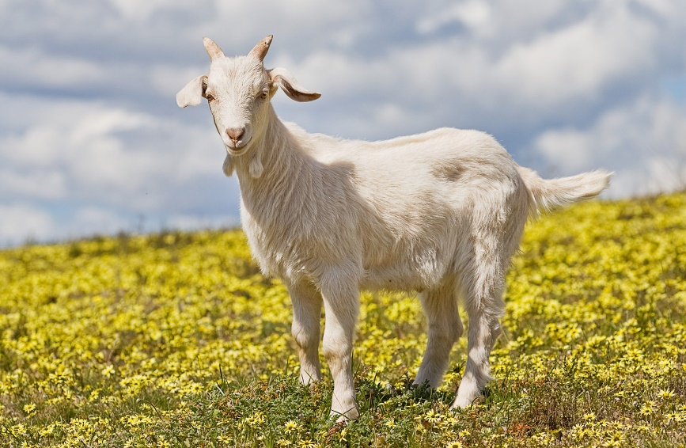

blizzard– a strong snowstorm

confidence –you believe that you can do something

continue – to keep doing something

decide– to make a choice about something

patiently- to not get upset

peasant- European small farm worker

shelter- something covers and protect you

trust- means to believe that they will do what is best for you

