Weekly Snapshot
Week of April 1, 2019

Monday, April 1, 2019
Learning Strategies
Mindfulness Monday
Goal Setting
UNIT: Psychology and Sociology

6th Grade Weekly Selection: “The Forgotten Treasure”
Introduction: Vocabulary
Activating Prior Knowledge: watch video on folk tales
Focus on Genre- Folk Tales
Read Aloud and Discuss Elements- Ask Questions
Homework- Learn Key Vocabulary

7th & 8th Grade Weekly Selection: “Angels in the Snow”
Introduction: Vocabulary
Activating Prior Knowledge- brief video on female firefighter facts
Focus on Genre- online news article
Read Aloud and Discuss Elements-author’s viewpoint
Homework-Learn Key Vocabulary
Tuesday, April 2, 2019

Learning Strategies
Talk About it Tuesday
UNIT: Psychology and Sociology

6th Grade Weekly Selection: “The Forgotten Treasure”
Review Vocabulary & Homework
Audio of Story
Grammar- Use of Verb Tense: Be and Have
Homework-Use of Verb Tense: Be and Have

7th & 8th Grade Weekly Selection: “Angels in the Snow ”
Review Vocabulary & Homework
Audio of Story
Grammar-Prepositions
Homework-Prepositions
Wednesday, April 3 , 2019

Learning Strategies
Work on It Wednesday
Check Grades and Conference
Please check with your child about missing assignments and grades below C

6th Grade Weekly Selection: “The Forgotten Treasure”
Paired Reading of Text
Literary Analysis: Sequence
Text Structure: Suffixes
Vocabulary Study:
Homework: Academic Vocabulary

7th & 8th Grade Weekly Selection: “Angels in the Snow”
Paired Reading of Text
Vocabulary Study: Use Greek, Latin, and Anglo-Saxon Roots
Analyze: Author’s Viewpoint
Homework: Academic Vocabulary
Thursday, April 4 , 2019

Learning Strategies
Think About it Thursday
UNIT: Psychology and Sociology

ELA CLASSES
******************Practice for SBAC online ***********************************

Friday, April 5, 2019

Learning Strategies
Preferred and Non-Preferred Grouping
UNIT: Psychology and Sociology

6^{th,} 7th , & 8th Grade Weekly Selection
Reading Test
Writing Assessment Linked to Current Story

Vocabulary
“The Forgotten Treasure”

beautiful – very pretty

forest –a place with lots of trees

forget – to stop thinking about it

locate– to find something

loss– when you no longer have something important

remember –to think of it again later

skeleton–the set of bones in an animal or a person

treasure– something that is special and important

Vocabulary
“Angels in the Snow”
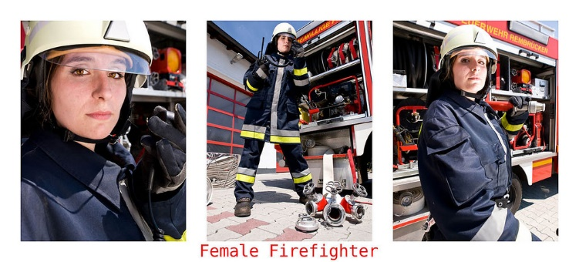

accident– is a sudden event that causes damage to people or things.

career –they type of work a person does

department – is a part of a larger group or business

difficult –hard to do

emergency- service helps people in serious situations

experience- knowledge or skill that comes from having already done something

region- a specific area

team- group that works together

