Weekly Snapshot
Week of April 22, 2019

Monday, April 22, 2019
Learning Strategies
Mindfulness Monday
Goal Setting
UNIT: Psychology – understanding terminology

6th Grade Weekly Selection: “Escaping to Freedom”
Introduction: Vocabulary
Activating Prior Knowledge: watch video on Josiah Henson
Focus on Genre- Biography
Read Aloud and Discuss Elements- Determine Importance
Homework- none

7th Grade Weekly Selection: Washington History Project
Students will be working on outline on Office 365
Students should have the following completed:
Introduction, Background, and beginning of topic

8th Grade Weekly Selection: “Play Ball!”
Introduction: Vocabulary
Activating Prior Knowledge-video on history of baseball
Focus on Genre- history article
Read Aloud and Discuss Elements-nonfiction text features
Homework-Learn Key Vocabulary
Tuesday, April 23, 2019

Learning Strategies
Talk About it Tuesday
UNIT: Psychology- conducting an experiment

6th Grade Weekly Selection: “Escaping to Freedom”
Review Vocabulary & Homework
Audio of Story
Grammar- Nouns in the subject and predicate
Homework- no homework

7th Grade Weekly Selection: Washington History Project
Students will work on the following:
Outline: Topic information & Sway Layout

8th Grade Weekly Selection: “Play Ball!”
Review Vocabulary & Homework
Audio of Story
Grammar- Use Complete Sentences
Homework-Complete Sentences
Wednesday, April 24, 2019

Learning Strategies
Work on It Wednesday
Check Grades and Conference
Please check with your child about missing assignments and grades below C

6th Grade Weekly Selection: “Escaping to Freedom”
Paired Reading of Text
Literary Analysis: cause and effect
Vocabulary Study: context clues
Homework: none

7th Grade Weekly Selection: Washington History Project
Students will write conclusion

8th Grade Weekly Selection: “Play Ball”
Paired Reading of Text
Vocabulary Study: context clues
Analyze: chronological order
Homework: chronological order
Thursday, April 25, 2019

Learning Strategies
Think About it Thursday
UNIT: Psychology- debate survey

ELA CLASSES
******************Practice for SBAC online ***********************************
Friday, April 26, 2019

Learning Strategies
Preferred and Non-Preferred Grouping
UNIT: Psychology – researching debate for class

6^{th,} & 8th Grade Weekly Selection
Reading Test
Writing Assessment Linked to Current Story

7th Grade Weekly Selection: Washington History Project
Students will login to Office 365 Sway and begin Slide 1

Vocabulary
“Escaping to Freedom”

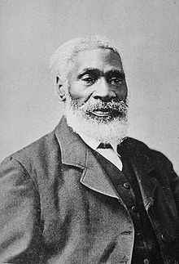

assist – means to help

capture –to take by force; the act of catching something

escape –to get away

freedom – state of being free

reward– money given for helping someone

right –the power a person has because of a country’s rules

slave–someone who belongs to another person who works without pay

tomb– is a grave or a special place for the body of a dead person

Vocabulary
“Play Ball!”
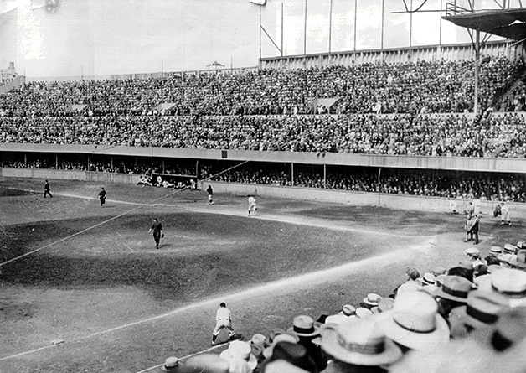

champion– a winner

compete – to take part in a contest

fan – someone who supports a particular team or person

league– a group of teams that play the same sport

pastime- an activity that you often do for fun

popular- means to be liked by many people

professional- someone who does a job for money

segregate - means to separate or keep apart

