Weekly Snapshot
Week of February 4, 2019

Monday, February 4, 2019
Learning Strategies
Mindfulness Monday
Goal Setting
Morning Meeting

6th Grade Weekly Selection: “Mister Monster”
Introduction: Vocabulary
Activating Prior Knowledge: watch video on plays
Focus on Genre- Plays
Read Aloud and Discuss Elements- Characters, Dialogue, and Stage Directions
Homework- Learn Key Vocabulary

7th & 8th Grade Weekly Selection: “When Cultures Meet”
Introduction: Vocabulary
Activating Prior Knowledge- brief video on Christopher Columbus
Focus on Genre- History Article
Notetaking: Analyze text Features
Read Aloud and Discuss Elements-facts and historical photographs
Homework-Learn Key Vocabulary
Tuesday, February 5, 2019

Learning Strategies
Talk About it Tuesday
Stress:
**********************************************************************************************************
Star 360 Assessment for all classes
****************************************************************************

Wednesday, February 6, 2019

Learning Strategies
Work on It Wednesday
Check Grades and Conference
Please check with your child about missing assignments and grades below C

6th Grade Weekly Selection: “Mister Monster”
Review Vocabulary & Homework
Audio of Story
Grammar- Adverbs
Homework-Adverbs

7th & 8th Grade Weekly Selection: “When Cultures Meet ”
Review Vocabulary & Homework
Audio of Story
Grammar-Verbs in the Past Tense
Homework-Verbs in the Past Tense

Thursday, February 7, 2019

Learning Strategies
Think About it Thursday
Stress: Conflict Resolution

6th Grade Weekly Selection: “Mister Monster”
Paired Reading of Text
Literary Analysis: Analyze Rhythm in Poetry
Vocabulary Study: Compare Literature & Prefixes
Homework: Academic Vocabulary

7th & 8th Grade Weekly Selection: “When Cultures Meet”
Paired Reading of Text
Vocabulary Study: Analyze Idioms & Close Reading “The Log of Christopher Columbus”
Homework: Idioms

Friday, February 8, 2019

Learning Strategies
Preferred and Non-Preferred Grouping
Stress: Conflict Resolution

6^{th,} 7th , & 8th Grade Weekly Selection
Reading Test
Writing Assessment Linked to Current Story

Vocabulary
“Mister Monster”

amazed – to be very surprised

apply – means to ask for or request something

audience – a group of people who watch or listen to something

commercial–an ad on the TV or radio

disappear–means to no longer be seen

mascot –a character that represents an organization

offstage–to be at the side of the stage

response– is what people think or say about something

Vocabulary
“Where Cultures Meet”
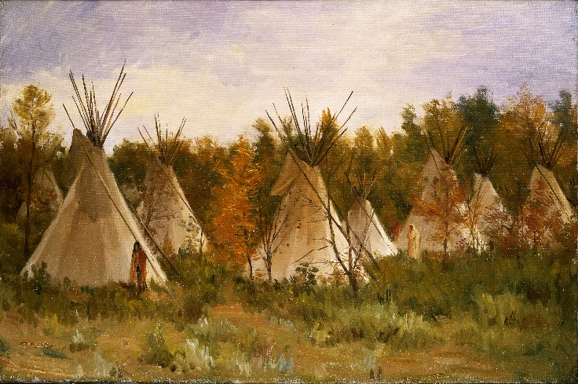

contact– the act of meeting or communicating

crop – a type of plant grown in large amounts to eat or use

forever- means a time without end

route – a path that leads somewhere

settler- people who move to a new area to live

spread- it moves across a larger area

starve – means to not have enough food to live

tool– something that makes work easier

