Weekly Snapshot
Week of March 25, 2019

Monday, March 25, 2019
Learning Strategies
Mindfulness Monday
Goal Setting
UNIT: Psychology and Sociology

6th Grade Weekly Selection: “Return to the Titanic”
Introduction: Vocabulary
Activating Prior Knowledge: watch video on Titanic
Focus on Genre- History Article
Read Aloud and Discuss Elements- Ask Questions
Homework- Learn Key Vocabulary

7th & 8th Grade Weekly Selection: “Dogs at Work”
Introduction: Vocabulary
Activating Prior Knowledge- brief video on mushers
Focus on Genre- magazine article
Read Aloud and Discuss Elements-author’s purpose and tone
Homework-Learn Key Vocabulary
Tuesday, March 26, 2019

Learning Strategies
Talk About it Tuesday
UNIT: Psychology and Sociology

6th Grade Weekly Selection: “Return to Titantic”
Review Vocabulary & Homework
Audio of Story
Grammar- Present and Past tense Verbs
Homework-Present and Past tense verbs

7th & 8th Grade Weekly Selection: “Dogs at Work ”
Review Vocabulary & Homework
Audio of Story
Grammar-Nouns in the Subject and Predicate
Homework-Nouns in the Subject and Predicate
Wednesday, March 27, 2019

Learning Strategies
Work on It Wednesday
Check Grades and Conference
Please check with your child about missing assignments and grades below C

6th Grade Weekly Selection: “Return to Titanic”
Paired Reading of Text
Literary Analysis: Word Parts (prefix and Suffix)
Text Structure: Sequence
Vocabulary Study:
Homework: Academic Vocabulary

7th & 8th Grade Weekly Selection: “Dogs at Work”
Paired Reading of Text
Vocabulary Study: Word Origins & Determining Viewpoints
Homework: Academic Vocabulary
Thursday, March 28, 2019

Learning Strategies
Think About it Thursday
UNIT: Psychology and Sociology

ELA CLASSES
******************STAR 360 ASSESSMENT***********************************

Friday, March 29, 2019

Learning Strategies
Preferred and Non-Preferred Grouping
UNIT: Psychology and Sociology

6^{th,} 7th , & 8th Grade Weekly Selection
Reading Test
Writing Assessment Linked to Current Story

Vocabulary
“Return to Titanic”

alarm – warns people of danger

discover –means to find something that is lost hidden.

explorer – travels somewhere to study something

famous– is very well known

ocean–a large area or body of salt water

passenger –ride in a boat, car, or other vehicles

search –to look for something

wreck– what is left after a crash

Vocabulary
“Dogs at Work”
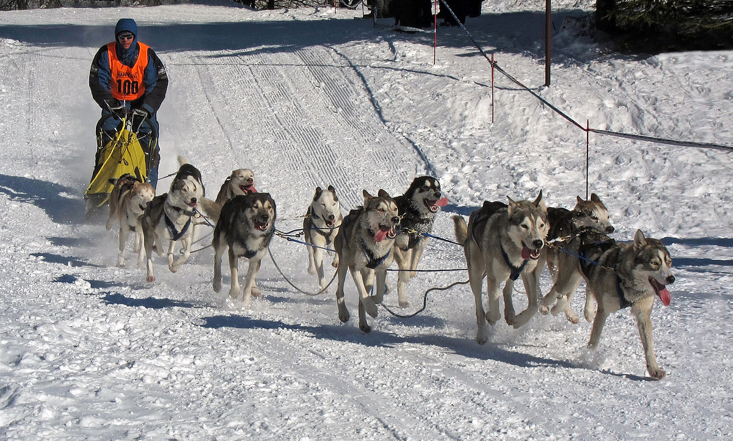

dependable– person can be trusted to do the right thing

employee –a person who works for someone else

job- work you do

obedient –you do what you are told

odor- a smell

search- means to look for it

service –something done to help someone else

train-to teach that person to do something

