Weekly Snapshot
Week of November 5, 2018

Monday, November 5, 2018

Learning Strategies
Mindfulness Monday
Morning Meeting
Are you living in the Drama Triangle or the Winner’s Triangle?

6th Grade Weekly Selection: “Water at Work”
Introduction: Vocabulary
Activating Prior Knowledge: video on water used for dams
Focus on Genre- Social Science Article
Read Aloud and Discuss Elements- infer, predict, and synthesize
Homework- vocabulary cards

7th & 8th Grade Weekly Selection: “Brothers in Hope”
Introduction: Vocabulary
Activating Prior Knowledge: video on the geography of Sudan
Focus on Genre- biographical fiction
Read Aloud and Discuss Elements-chronological order
Homework: vocabulary cards
Tuesday, November 6, 2018

Learning Strategies
Talk About it Tuesday
Finish the Growth Mindset Packet

6th Grade Weekly Selection: “Water at Work”
Review Vocabulary & Homework
Audio of Story
Grammar-make subjects and verbs agree
Homework- grammar

7th & 8th Grade Weekly Selection: “Brothers in Hope”
Review Vocabulary & Homework
Audio of Story
Grammar- Adverbs
Homework-Adverbs
Wednesday, November 7, 2018

Learning Strategies
Check Grades and Conference
Please check with your child about missing assignments and grades below C

6th Grade Weekly Selection: “Water at Work”
Review Homework
Read story in pairs
Analyze Text Structure: Main Idea and Details /Synonyms & Antonyms

7th & 8th Grade Weekly Selection: “Brothers in Hope”
Review Homework
Read the story in groups
Analyze Text Structure: Compare Fiction and Nonfiction/Root Words/

Thursday, November 8, 2018

Learning Strategies
Think About it Thursday
Classroom Expectations

6th Grade Weekly Selection: “Water at Work”
Paired Reading of Text
Grade Level Reading Comprehension or Phonics
Homework: Study Vocabulary Words

7th & 8th Grade Weekly Selection: “Brothers in Hope”
Paired Reading of Text
Grade Level Reading Comprehension
Homework: Comprehension/Study Vocabulary Words
Friday, November 9, 2018

Learning Strategies
Preferred and Non-Preferred Grouping
Continue Project Based Learning Activity: Building a Taco Truck

6^{th,} 7th , & 8th Grade Weekly Selection
Reading Test
Writing Assessment

Vocabulary
“Water at Work”

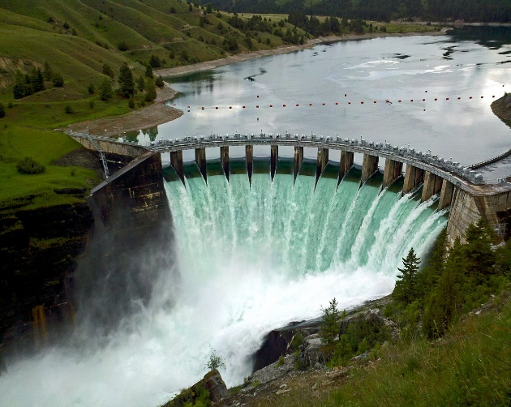

arrive – means to reach a place

electricity – a form of energy

flow – means to move freely

generate – means to make something

goods – things that people buy and sell

power – energy that makes things work

safely –to do without danger

treat – change it
Vocabulary
“Brothers in Hope”
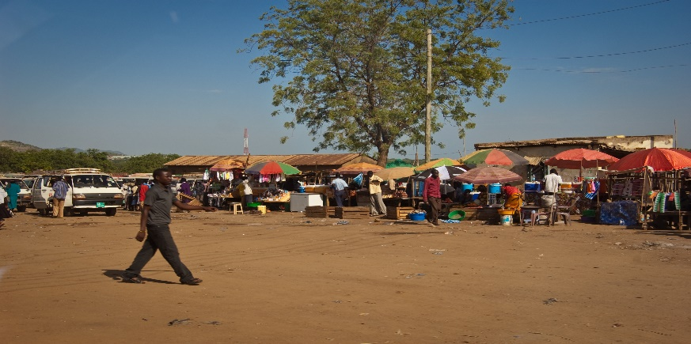

cross –you go from one side to another

dangerous – not safe

education – everything you learn

effort – you try harder

emerge- come out of it

improve- to make it better

journey – a long trip

tend – you take care of it

