Weekly Snapshot
Week of November 12, 2018

Monday, November 12, 2018

Tuesday, November 13, 2018

Learning Strategies
Talk About it Tuesday
Morning Meeting

6th Grade Weekly Selection: “Volcano!”
Introduction: Vocabulary
Activating Prior Knowledge: watch video of volcanoes
Focus on Genre- Science Article
Read Aloud and Discuss Elements-making connections /Text Features: Diagrams
Homework- workbook vocabulary pages

7th & 8th Grade Weekly Selection: “The Human Machine”
Introduction: Vocabulary
Activating Prior Knowledge: watch video of Megan Quann- Olympic Swimmer
Focus on Genre- Science Article
Read Aloud and Discuss Elements- technical terms and diagrams/Interpret and Analyze Visuals
Homework: vocabulary pages from workbook

Wednesday November 14, 2018
Learning Strategies
Check Grades and Conference
Please check with your child about missing assignments and grades below C

6th Grade Weekly Selection: “Volcano!”
Review Vocabulary & Homework
Audio of Story
Grammar-Subject Pronouns
Homework-Subject Pronouns

7th & 8th Grade Weekly Selection: “The Human Machine”
Review Homework
Finish Reading Story Aloud
Grammar: Possessive Nouns
Homework: Possessive Nouns

Thursday, November 15, 2018

Learning Strategies
Think About it Thursday
Finish Classroom Expectations Packet

6th Grade Weekly Selection: “How Do We Use Water”
Paired Reading of Text
Text Analysis: Cause and Effect /Compound Words
Homework: Cause and Effect

7th & 8th Grade Weekly Selection: “The Human Machine”
Audio of Text
Text Analysis: Main Idea and Details/Context Clues
Homework: Context Clues
Friday, November 16, 2018

Learning Strategies
Preferred and Non-Preferred Grouping
Continue Project Based Learning Activity: Building a Taco Truck

6^{th,} 7th , & 8th Grade Weekly Selection
Reading Test
Writing Assessment

Vocabulary
“Volcano!”

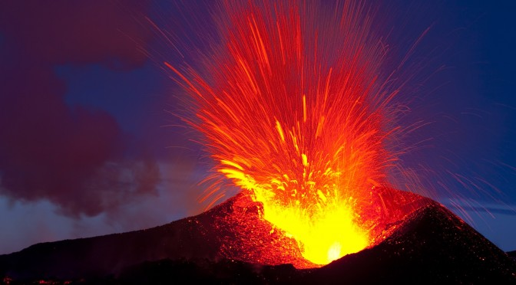

active – likely to move or show action

dangerous – not safe

erupt –to break open or shoot out suddenly

force – to push or is a great power in nature

layer – a section that is on top of or under another

surface –outside part of something

volcano –an opening in Earth from which lava, ash, and steam erupt

warning – a sign that something bed may happen

Vocabulary
“The Human Machine”

cell –the smallest working part of a living thing

circulate – it moves along a path that returns to the place it started

examine – to look at it very closely

involve – to be part of something

organ- a body part that has a certain job to do

oxygen- the air we breathe

system – group of parts that work together to do a job

vessel– a tube through which liquid travels in a living thing

