Weekly Snapshot
Week of November 19, 2018

Monday, November 19, 2018

Learning Strategies
Mindfulness Monday
Morning Meeting

6th Grade
Writing: Acrostic Poem: Grateful
Comprehension: “Mayflower Myths”
Homework: None

7th & 8th Grade
Writing: Acrostic Poem: Grateful
Comprehension: “Where Does Your Food Come From?”
Homework: None

Tuesday, November 20, 2018

Learning Strategies
Talk About it Tuesday
Executive Functioning Packet

6th Grade
Writing: Should Stores open on Thanksgiving? Paragraph Writing
Comprehension: “Thanksgiving in London”
Homework: None

7th & 8th Grade
Writing: Should Stores open on Thanksgiving? Paragraph Writing
Comprehension: “Thanksgiving Fact or Fiction”
Homework: None

Wednesday November 21, 2018

Learning Strategies
Check Grades and Conference
Please check with your child about missing assignments and grades below C

6th Grade
Writing: Top 10 List
Comprehension: “First Thanksgiving Meal”
Homework: None

7th & 8th Grade
Writing: Top 10 List
Comprehension: “Thanksgiving History: the Pilgrims, the Civil War, and a 60 foot Rubber Dinosaur_
Homework: none
Thursday, November 22, 2018
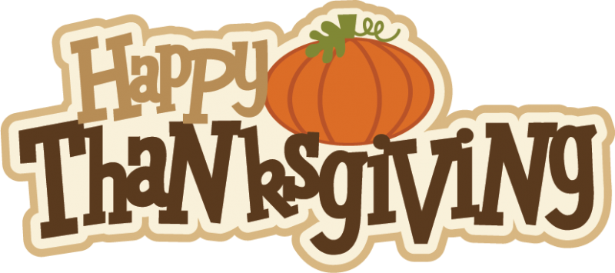

Friday, November 23, 2018
