Weekly Snapshot
Week of October 1, 2018

Monday, October 1, 2018

Learning Strategies
Mindfulness Monday
Morning Meeting
The Five Point Scale

6th Grade Weekly Selection: “The Secret Water”
Introduction: Vocabulary
Activating Prior Knowledge
Focus on Genre- Legend
Read Aloud and Discuss Elements- Story Elements (character, setting, text structure)
Homework-Make Study Cards of Vocabulary ( word on front, definition on back)

7th & 8th Grade Weekly Selection: “The Lotus Seed”
Introduction: Vocabulary
Activating Prior Knowledge
Focus on Genre- Realistic Fiction
Read Aloud and Discuss Elements-
Homework-Make Study Cards of Vocabulary (word on front, definition on back)
Tuesday, October 2, 2018

Learning Strategies
Talk About it Tuesday
Classroom Expectations: Relationship Builders and Damagers/Reflections

6th Grade Weekly Selection: “The Secret Water”
Review Vocabulary & Homework
Audio of Story
Grammar-Use of Nouns
Homework-none

7th & 8th Grade Weekly Selection: “The Lotus Seed”
Review Vocabulary & Homework
Audio of Story
Grammar- Adjectives that Describe
Homework- Selection Review
Wednesday, October 3, 2018

Learning Strategies
Work on It Wednesday- Conference & Chat
Please check with your child about missing assignments and grades below C

6th Grade Weekly Selection: “The Secret Water”
Literacy Analysis Reading Strategies- Analyze Plot & Create Word Categories
Homework: study vocabulary

7th & 8th Grade Weekly Selection: “The Lotus Seed”
Literacy Analysis Reading Strategies-Analyze Plot
Homework:
Thursday, October 4, 2018

Learning Strategies
Think About it Thursday
Growth Mindset Unit-SELF-TALK “I can choose my thoughts when things get challenging”

6th Grade Weekly Selection: “The Secret Water”
Paired Reading of Text
Grade Level Reading Comprehension or Phonics
Homework: Review Vocabulary

7th & 8th Grade Weekly Selection: “The Lotus Seed”
Paired Reading of Text
Grade Level Reading Comprehension
Homework: Academic Vocabulary Review
Friday, October 5, 2018

Learning Strategies
Preferred and Non-Preferred Grouping

6^{th,} 7th , & 8th Grade Weekly Selection
Reading Test
Writing Assessment

Vocabulary
“The Secret Water”

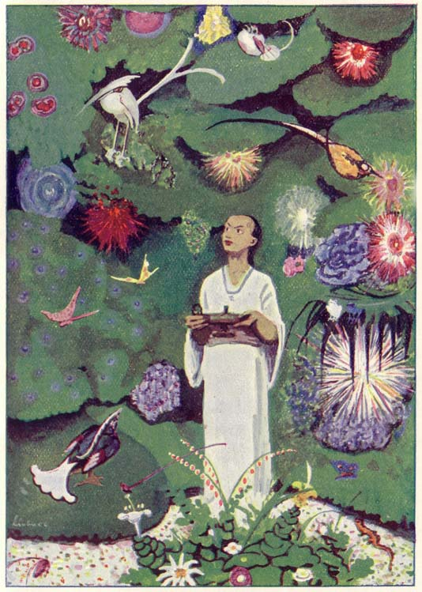

available – it is here and ready to go

perfect - just right

plan - an idea on how to do something

problem - something that is wrong

secret - something that is hidden from others or something you hide

statue –a model of a person or thing

village –a very small town

worry –means to feel unhappy and afraid about what may happen

Vocabulary
“The Lotus Seed”
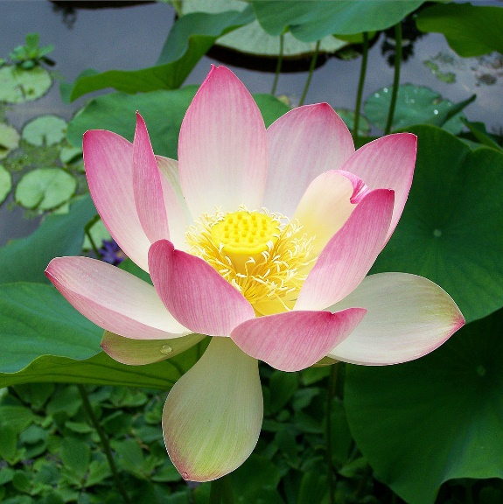

arrive –you get to a place

bloom – to open up or turn into a flower

chapter – one part of something

emperor – a ruler

forget- to no longer know it

remember- to think of it again

special – to be different and important

throne – a special chair where a royal person sits

