Weekly Snapshot
Week of October 29, 2018

Monday, October 29, 2018

Learning Strategies
Mindfulness Monday
Morning Meeting
Are you living in the Drama Triangle or the Winner’s Triangle?

6th Grade Weekly Selection: “How Do We Use Water?”
Introduction: Vocabulary
Activating Prior Knowledge: watch video on water on the Earth
Focus on Genre- Social Science Article
Read Aloud and Discuss Elements- photos and captions/interpret and respond
Homework- Write each vocabulary word in a meaningful sentence so you will know what the word means.

7th & 8th Grade Weekly Selection: “Immigrants Today”
Introduction: Vocabulary
Activating Prior Knowledge
Focus on Genre- Realistic Fiction
Read Aloud and Discuss Elements-
Homework
Tuesday, October 30, 2018

Learning Strategies
Talk About it Tuesday
Check Grades and Conference (Switching because Wednesday is Halloween)
Please check with your child about missing assignments and grades below C

6th Grade Weekly Selection: “How Do We Use Water”
Review Vocabulary & Homework
Audio of Story
Grammar-Use Complete Sentences
Homework-Correct the sentences

7th & 8th Grade Weekly Selection: “Immigrants Today”
Review Vocabulary & Homework
Audio of Story
Grammar- Adjectives that Compare
Homework-Adjectives
Wednesday, October 31, 2018

Learning Strategies
Halloween Cooperative Learning Activity
How many cars can race across my bone bridge?

6th Grade Weekly Selection: Halloween Jigsaw Activity
Halloween Reading Jigsaw Activity
Homework: Check your candy before eating it!

7th & 8th Grade Weekly Selection: Halloween Jigsaw Activity
Halloween Reading Jigsaw Activity
Homework: Check your candy before eating it!
Thursday, November 1, 2018

Learning Strategies
Think About it Thursday
Project Based Learning: Building a Taco Truck

6th Grade Weekly Selection: “How Do We Use Water”
Paired Reading of Text
Grade Level Reading Comprehension or Phonics
Homework: Study Vocabulary Words

7th & 8th Grade Weekly Selection: “Immigrants Today”
Paired Reading of Text
Grade Level Reading Comprehension
Homework: making comparisons comprehension
Friday, November 2, 2018

Learning Strategies
Preferred and Non-Preferred Grouping
Continue Project Based Learning Activity: Building a Taco Truck

6^{th,} 7th , & 8th Grade Weekly Selection
Reading Test
Writing Assessment

Vocabulary
“How Do We Use Water”

alive – something that is living

amount – total number or quantity

crop – plants that farmers grow

depend – something you need

globe – a model of the earth

material –things you need to make a product or do a project

rainfall –the total rain, snow, or sleet that falls in a period of time

resource – something that people need or use

Vocabulary
“Immigrants Today”
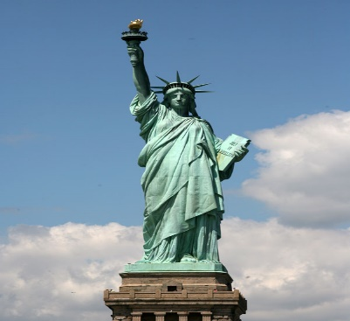

adjust –you become used to it

community – a group of people who live in one place

foreign – to be from somewhere else

immigrant – someone who moves from one country to another

local- means nearby

museum- people can look at art or other valuable objects

poverty – is the state or condition of being poor

preserve – means to keep something from being lost

