Weekly Snapshot
Week of September 24, 2018

Monday, September 24, 2018

Learning Strategies
Mindfulness Monday
Morning Meeting
The Five Point Scale

6th Grade Weekly Selection: “Familiar Places”
Introduction: Vocabulary
Activating Prior Knowledge
Focus on Genre-Expository Nonfiction
Read Aloud and Discuss Elements- Look at headings, pictures, and captions to preview text
Homework- Write a sentence with each vocabulary word

7th & 8th Grade Weekly Selection: “A Contest of Riddles”
Introduction: Vocabulary
Activating Prior Knowledge
Focus on Genre- Play
Read Aloud and Discuss Elements-dialogue, stage directions, actors/actresses
Homework-Write a sentence with each vocabulary word
Tuesday, September 25, 2018

Learning Strategies
Talk About it Tuesday
Classroom Expectations: Lesson 3

6th Grade Weekly Selection: “Familiar Places”
STAR 360
Homework: none

7th & 8th Grade Weekly Selection: “A Contest of Riddles”
STAR 360
Homework: none
Wednesday, September 26, 2018

Learning Strategies
Work on It Wednesday- Conference & Chat
Please check with your child about missing assignments and grades below C

6th Grade Weekly Selection: “Familiar Places”
Grammar- Use Statements and Commands
Homework: grammar

7th & 8th Grade Weekly Selection: “A Contest of Riddles”
Grammar- use subjects and verbs
Homework: grammar
Thursday, September 27, 2018

Learning Strategies
Think About it Thursday
Growth Mindset Unit- Lesson 2

6th Grade Weekly Selection: “Familiar Places”
Paired Reading of Text
Analyze Text Structure- Main Idea
Homework: Review Vocabulary

7th & 8th Grade Weekly Selection: “A Contest of Riddles”
Paired Reading of Text
Analyze Text Structure-Synonyms and Antonyms
Homework: Review Vocabulary
Friday, September 28, 2018

Learning Strategies
Preferred and Non-Preferred Grouping
STEM ACTIVITY- The Great Desert Island Stem Challenge- Part 1

6^{th,} 7th , & 8th Grade Weekly Selection
Reading Test
Writing Assessment

Vocabulary
“Familiar Places”

agree- to have the same ideas

community- a place where people live, work, and play

familiar- something that is already known

festival- a special event or party

native- something that belongs to you because of where you were born

neighborhood- a place where people live and work together

population- means the number of people who live somewhere

tradition- an activity or belief that people share for many years

Vocabulary
“A Contest of Riddles”

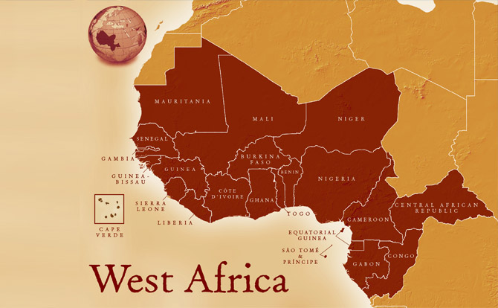

choice – is a decision

contest –is a game or test to see who is the best at something

excellent- very good

interpret – to figure out or explain what something means

knowledge- is what you know

nonsense- something that makes no sense

outcome – the result of something

response –an answer or reply

